Software Requirement Specification Document

For

Travel Hive
Travel Companion Matching System

Table of Contents
Page Numbers
- Introduction
  - Purpose
  - Intended Customers/Users
  - Product Scope
  - Outline of the document
- Overall Description
  - Product Perspective
  - Product Functions
  - User Classes
  - Design and Implementation Constraints
- Diagrams
  - UML Diagrams
  - ER Diagrams
  - DFD Diagrams
  - Assumptions and Dependencies
- External Interface Requirements/Screenshots
  - User Interfaces
  - Hardware Interfaces
  - Software Interfaces
  - Communication Interfaces
- Other Non-Functional Requirements
  - Performance Requirements
  - Safety Requirements
  - Security Requirements
  - Software Quality Attributes
  - Business Policies/Rules (if any)
- Testing
  - Block-Box Testing
  - White-Box Testing
- Conclusion
- References
- Acknowledgements

1.Introduction

1.1 Purpose
The purpose of Travel Hive system is to:
- Provides a web-based platform that enables travelers to identify and connect with others traveling
to the same destination on the same date.
- Facilitate the creation of temporary travel groups based on sharedjourney details and declared
travel intent.
- Assist users in coordinating travel related decisions, such as transport preferences and travel
timing, after discussions.
- Enhance the overall travel planning experience by supporting structured, controlled, and safe
group-based travel coordination.

1.2 Intended Customers/Users
The intended users of the Travel Hive system include:
- Individual Travelersplanningto go to some destinations and looking to coordinate their journey
with others.
- Students, Professionals, and general travelers who want a structured and safe way to plan group
travel without relying on social networks, booking platforms.

1.3 Product Scope
- Application Area/ Usage: The system supports travel planningCoordinationby allowing users to
form groups, communicate within the group, and track travel readiness, without handling ticket
booking.
- Target Domain: The software belongs to the travel and tourism domainand supports leisure,
educational, business, religious, and event-basedtravel.
- Deployment Environment: Travel Hive is a web application that can be accessed using a web browser on desktops, laptops, and mobile devices with internet access.
- Operational Conditions: The system is used mainly before and during a journey. Each travel group is active only for the trip duration and isclosed automatically after completion.

1.4 Outline of the Document
- Introduction: Describes the purpose of the SRS, the intended users, productscope, and how the document is organized.
- Overall Description: Gives an overview of the system, its main functions,user types, and any design or implementation constraints.
- System Design and Diagrams: Shows UML, ER, and DFD diagrams, alongwith assumptions and dependencies.
- External Interfaces and Non-Functional Requirements: Explains how the system interacts with users, hardware, software, networks, and listsperformance, security, safety, and quality requirements.
- Testing, Conclusion, and References: Details testing methods, summarizes the document, and includes references and acknowledgement.
2. Overall Description

2.1 Product Perspective
- Independent System: Travel Hive is a standalone web applicationthat does not rely on external software or services for its core functions.
- User-Focused Coordination: The system is designed to help travelers to formtemporary groups and coordinate travel plans safely and efficiently.
- Non-Transactional Platform: The software does not handle ticket booking,payments, or transport services. It only assists in finding travel partners, planning and communication.
- Data and Privacy Management: All travel data is journey specific, time-limitedand managed to ensure privacy and relevance.

2.2 Product Functions
- User Login and Logout: The system provides secure login access for registered users and allows them to safely log out after using theplatform.
- User Profile Management: Users can create, view, and updatepersonal information and travel preferences to receive relevant journey details
- Destination Browsing and Selection: The system displays all destinations in one section and shows the number of travelers and their travel dates whena destination is selected.
- Journey Grouping, Safety, and Travel Insights: The system allows users to create or join travel groups and provides safety guidelines, climate, and weather information for the selected destination.

2.3 User Classes
- Users (Travelers): Users can browse destinations and travel information, andafter login, manage profiles and create or join travel groups.
- System Administrator: The administrator manages destinations and system Content, monitors user activities, ensures platform security, and maintains overall system performance.
- Guest Users: Guest users can access the platform without creating an account or logging in. They are able to view general destination information and basic travel details. However, to create profiles, join travel groups, or communicate with other travelers, they must register and log in to the system.

2.4 Design and Implementation Constraints
- The system must be accessible through standard web browsers, support multiple devices, and follow standard web development technologies.
- User authentication, data handling, and database design must ensure security, privacy, and scalability.
- The system relies on internet connectivity and third-party services for weather, climate, and location information.
- The application must deliver reliable performance under varying user loads and automatically close travel groups after journey completion.

3. Diagrams

3.1 UML Diagrams
a): Use-Case Diagrams.

i) Module 1: User Account & Identity Management.
Description: This module manages user accounts for Travel Hive, includingregistration,
verification, login, authentication, deactivation and logout.
Primary Actor: User.
Secondary Actor: Notification Service.

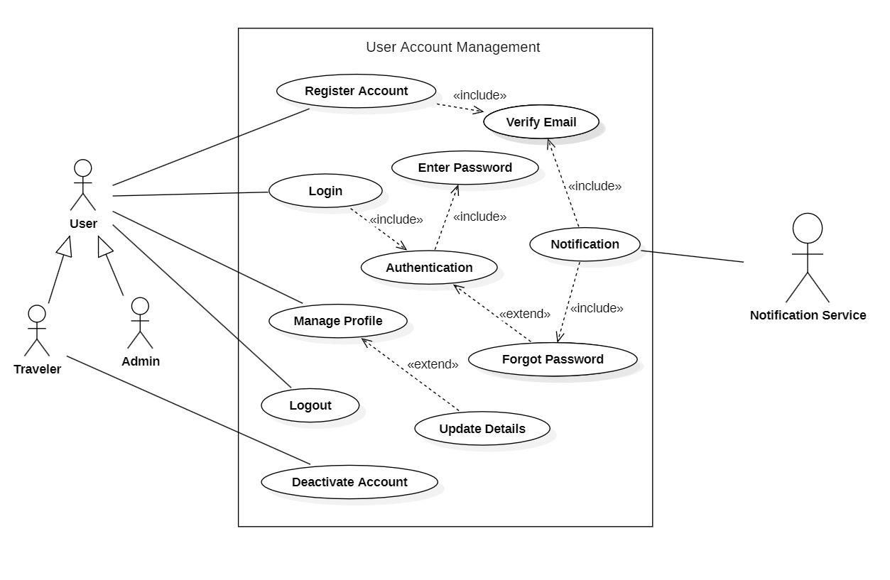

ii) Module 2: Travel Plan & Trip Management

Description: This module allows Travelers to plan and manage trips. Users cancreate travel
itineraries, select destinations, add activities, schedule dates, and update or delete trips as
needed and they can track ongoingtrips, view trip history, and manage all travel-related
information.
Primary Actor: User.
Secondary Actor: Admin.

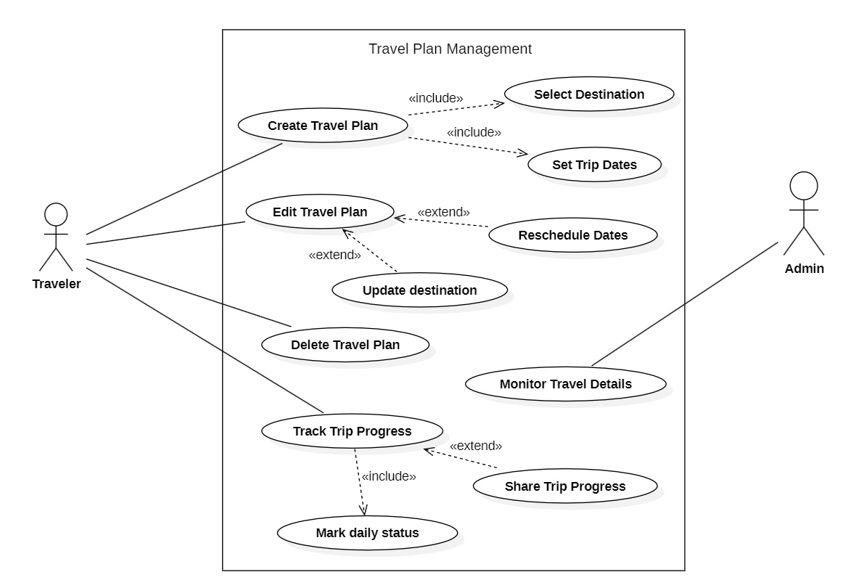

iii) Module 3: Travel Buddy Matching & Discovery.

Description: This module allows Travelers to connect with other Travelers who have similar
travelplans, interests, or destinations. This module helps users todiscover travel companions,
view their profiles, and communicate securely to plan shared trips.
Primary Actor: Traveler.
Secondary Actor: Notification Service.

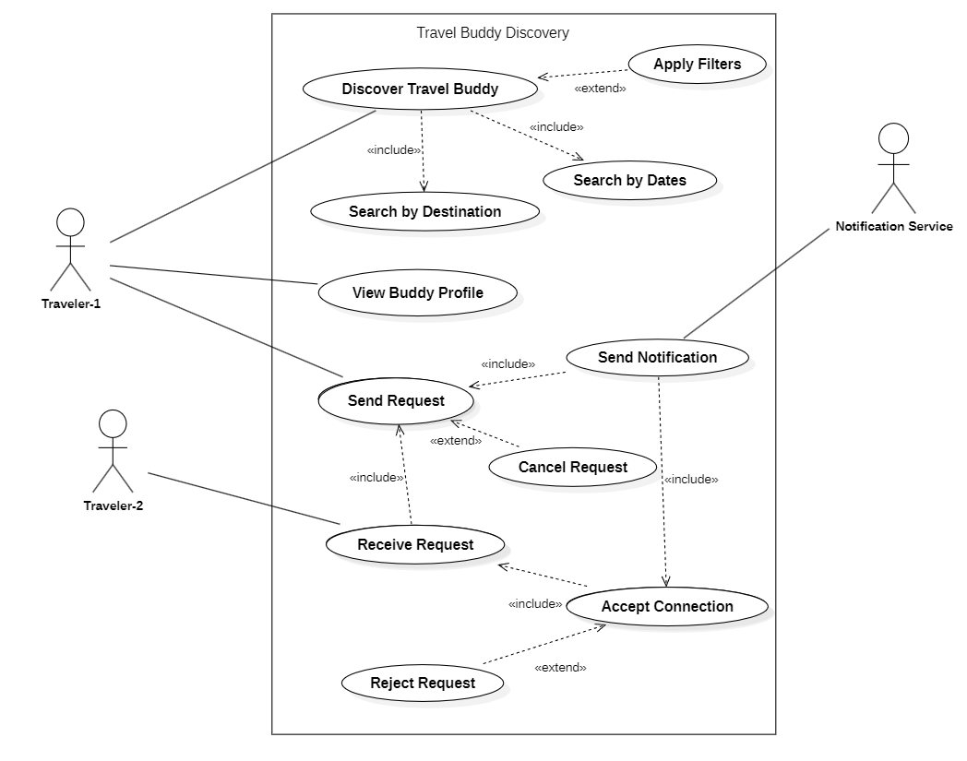

iv) Module 4: Buddy Interaction & Communication.

Description: This module allows connected travelers to communicate aftermatching. It provides
secure messaging, sharing of travel details, andcoordination of trip plans. Users can also form
and manage travel groups.
Primary Actor: Traveler, Admin.

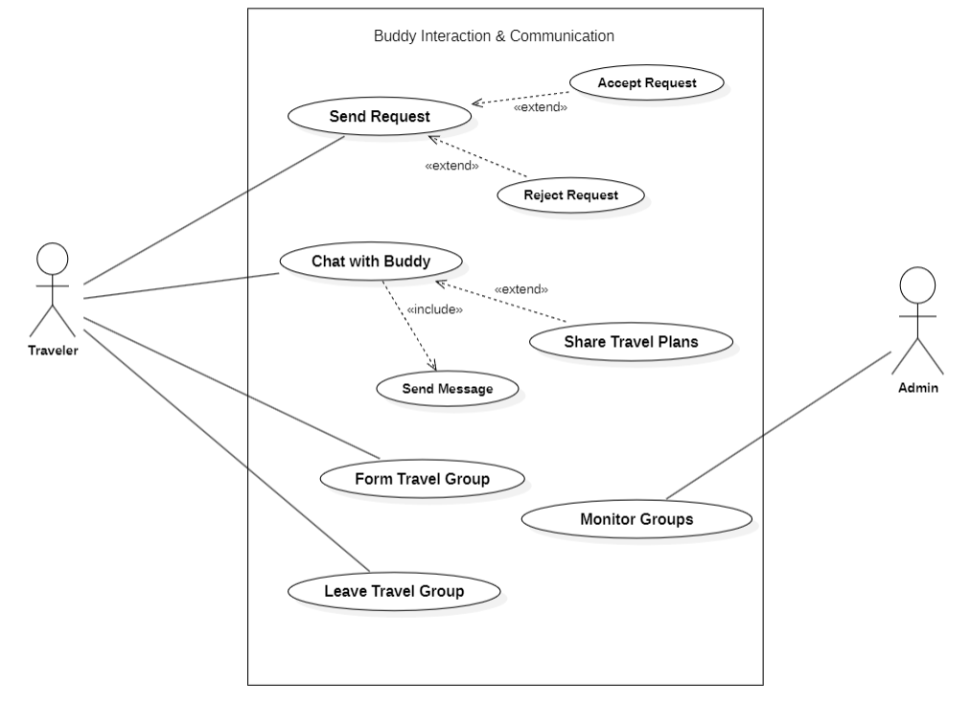

v) Module 5: System Management & Notification Module.

Description: This module lets admins manage users, monitor travel plans, handle reports, and
generate system reports, while enabling travelers toreceive notifications, match alerts, request
updates, view activity history,and control alerts, ensuring smooth system operation.

Primary Actor: Admin, Notification Service.
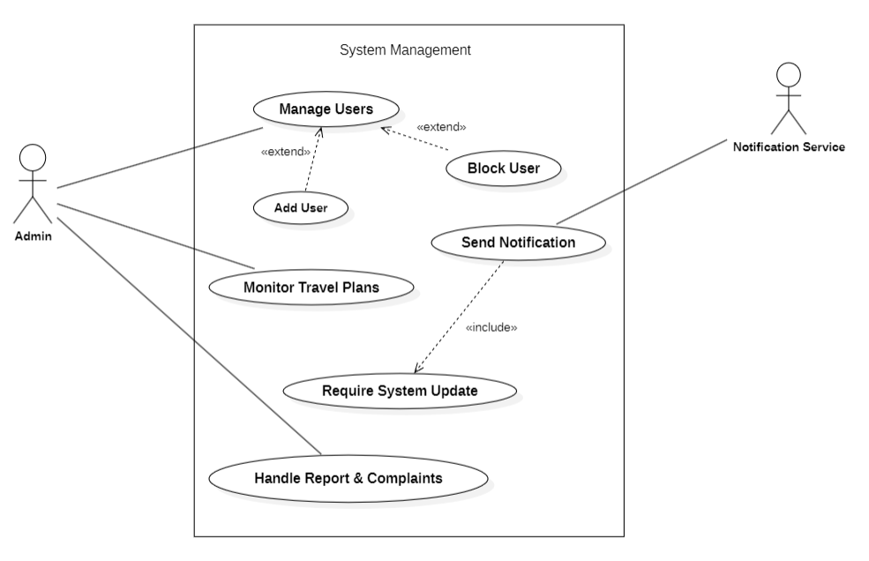

b):Class Diagrams.

i) Module 1: User Account & Identity Management.

Description:This diagram shows a user authentication system User, Credential, UserProfile, and
AuthenticationService classes. A user has a one-to-one relationship with Credential for login
details and a one-to-one composition with UserProfile, means the profile exists only with the
user. TheAuthenticationServicedepends on User and Credential to authenticate users and
validatecredentials but does not own them.

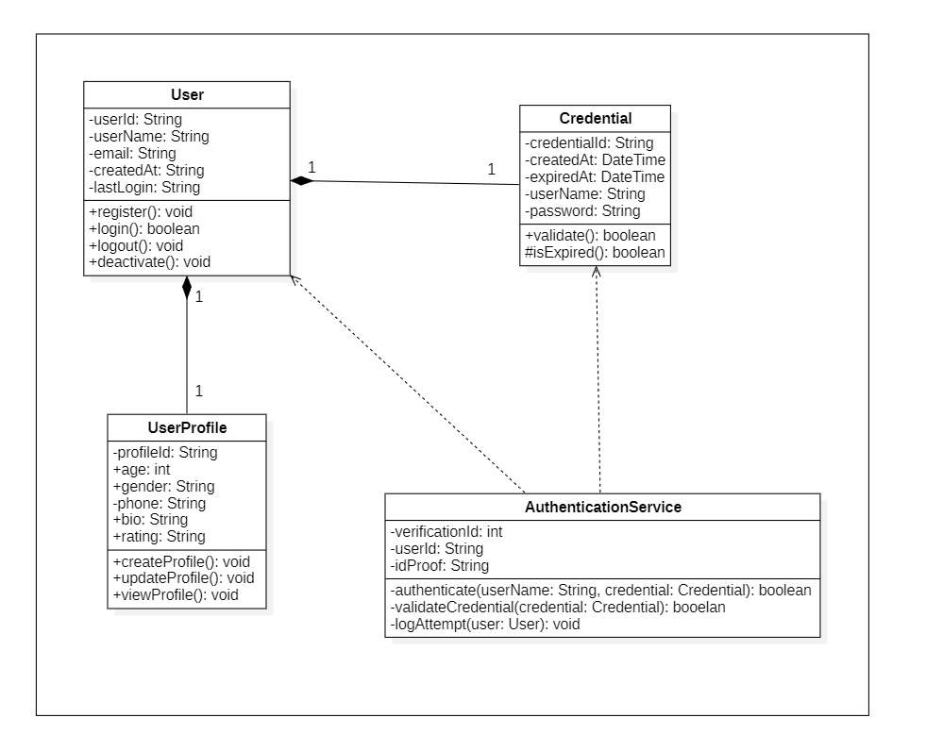

ii) Module 2: Travel Plan & Trip Management

Description:This Class represents, A user can create a multiple TripPlansand perform multiple
searches for trips. Each TripPlan can include TripPreferences. User can create, update, view
trips,while searches allow filtering and listing trips. The diagram shows relationships: one user
can have many trips and searches, and each trip can reference trip preferences.

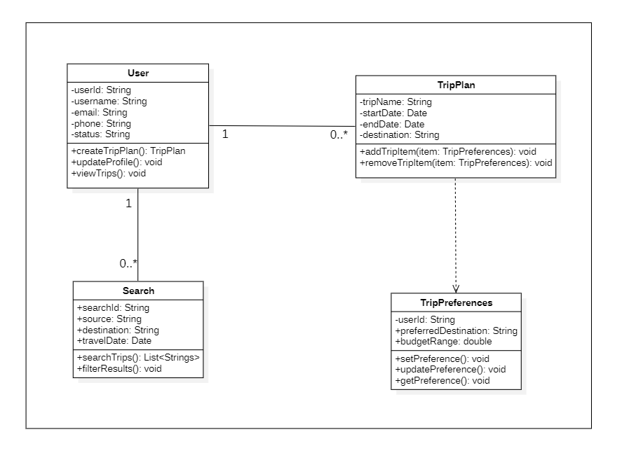

iii) Module 3: Travel Buddy Matching & Discovery.

Description: This Class diagram illustratesthat,a User creates a TravelProfileto specify travel
preferences and availability.Users can send and receive MatchRequests to find suitable travel
buddies.The diagram shows how user profiles, matching, and connect within the system.
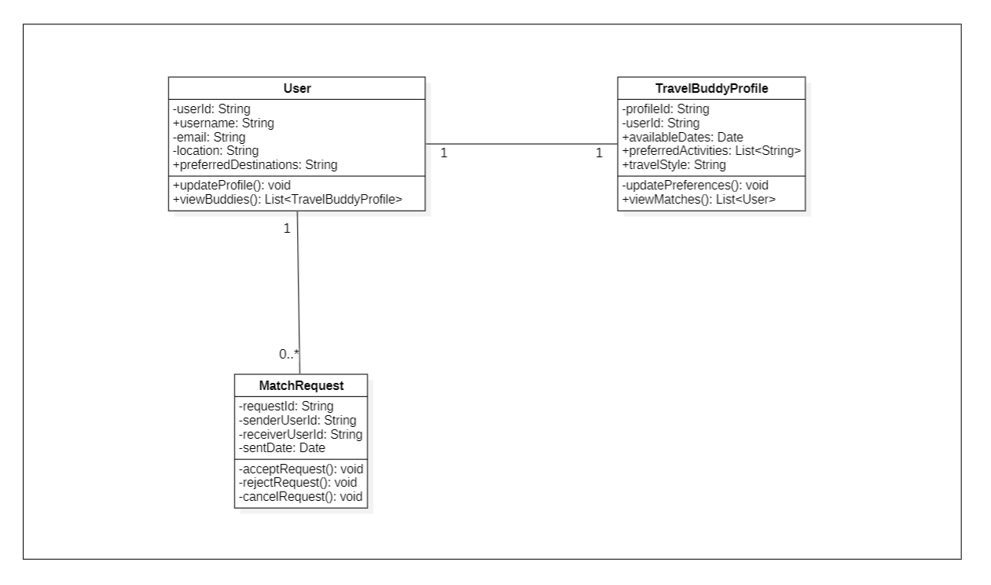

iv) Module 4: Buddy Interaction & Communication.

Description: The diagram represents a travel buddy communication system where a User is the
central entity. A user can have zero-or-many BuddyConnections, while each connection is
linked toone User. A User can also belong to zero-or-many Chat Groups, and each ChatGroup
contains one-or-many Messages in a composition relationship. Additionally, a User can receive
zero-or-many Notifications, with each notification associated with one user.
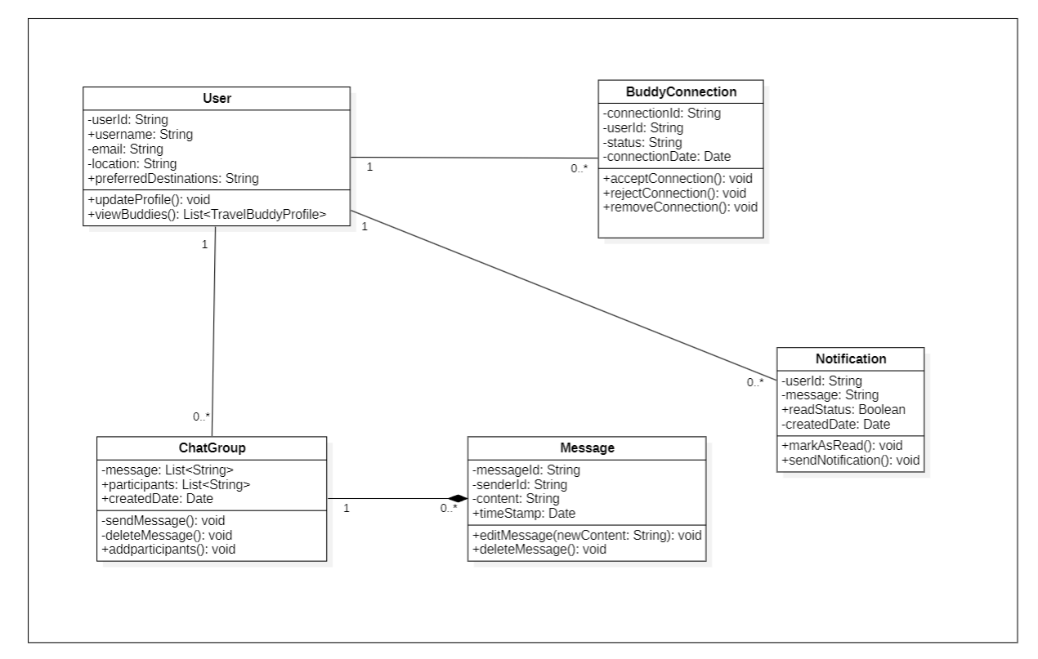

v) Module 5: System Management & Notification Module.

Description: The diagram shows a system where User is the base class and AdminUser inherits
from it. A User can receive zero-or-many Notifications., each linked to one user. An AdminUser
managesthe system and is associated with zero-or-many SystemLogs, while each log is recorded
by oneadmin. The AdminUser can also generate zero-or-many Notifications. The Settings class is
independent and manages configure system.
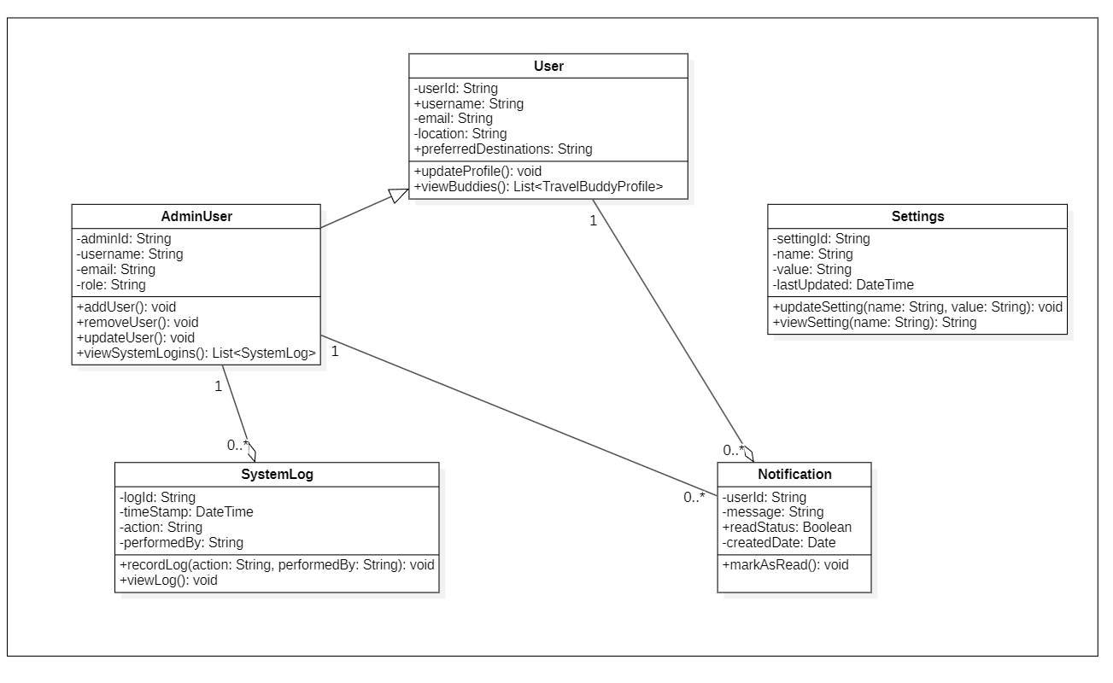

c) State Chart Diagrams

Module:Travel Buddy Matching & Discovery.

- Class: User
Description:This state diagram shows the various states of a user in the travel companion system and the transitions between them. The user begins in the logged-in state and move to profile update, search buddies, and viewing matches states. Upon finding companion, the user reaches to final state. If the user becomes inactive, the user can return to logged-in state.

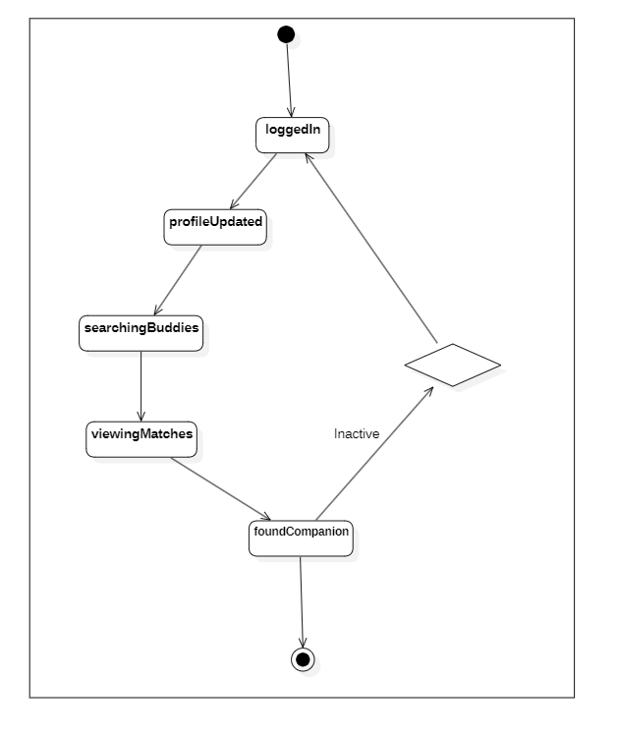

- Class: Travel Buddy Profile.

Description: This UML diagram shows the user profile workflow, starting with Profile creation, moving to ‘preferenceSet’ where we did it by branching into parallel tasks like ‘setDates’, ‘setDestination’, and ‘setBudget’. These merge into matchingProgressand then the process ends with ‘archived’.

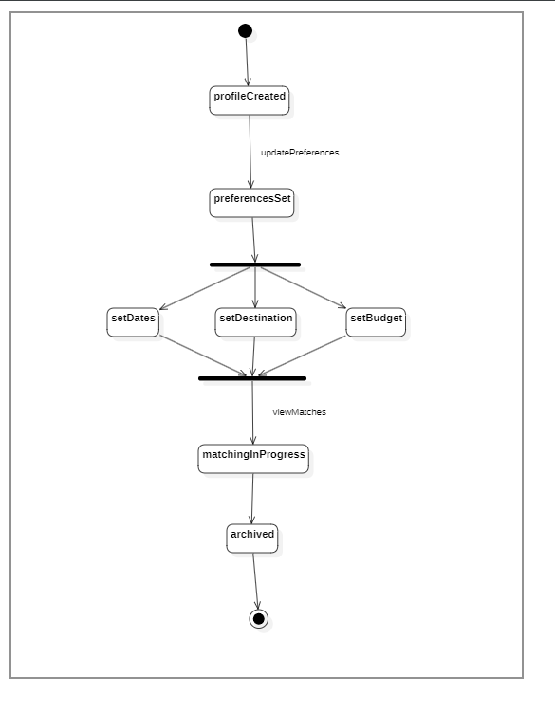

- Class: Match Request.

Description: This state diagram describes the cycle of match request in system. The request starts in the initiated state and moves to pending when a request is sent. From the pending state, the request can be accepted, rejected, or cancelled based on user actions. A rejected request may be retried and returned to initial state, while accepted or cancelled requests lead to final state. The diagram shows the possible states and transitions of a request over time.

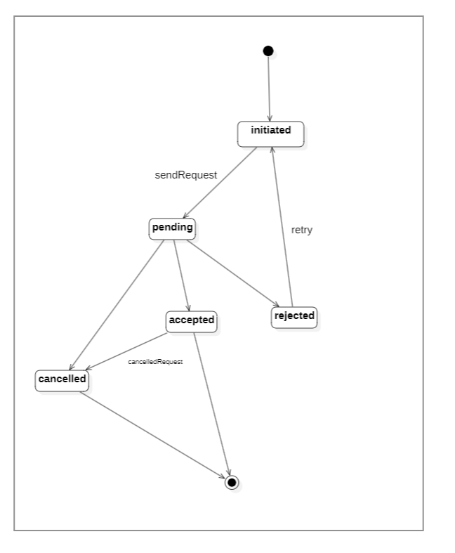

d) Activity Diagram

Description: This activity diagram shows the workflow of a Traveler using Travel Hive application.
Theuser opens the application and either creates a new profile or logs in if already registered. After
that user can create a profile by planning trip. Then user search for a travel companion, a request is
sent and accepted once the request is approved, chat is enabled and the trip is accepted,
completing the process.

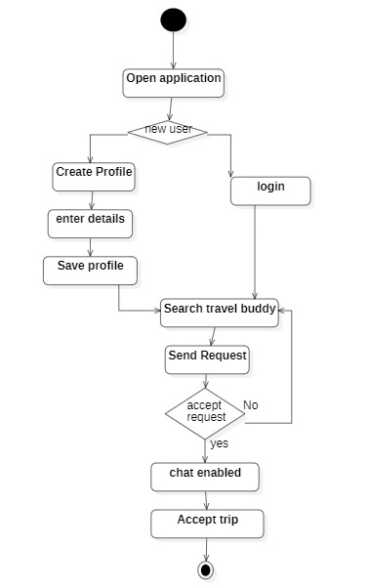

e) Sequence Diagram

i) User Account &Identity Management.
Description: This diagram illustrates how the user interacts with the credential, Authentication
Service, and UserProfile. The user creates credentials and a profile, authenticates through the
service, and upon successful validation, can view and update their profile information.

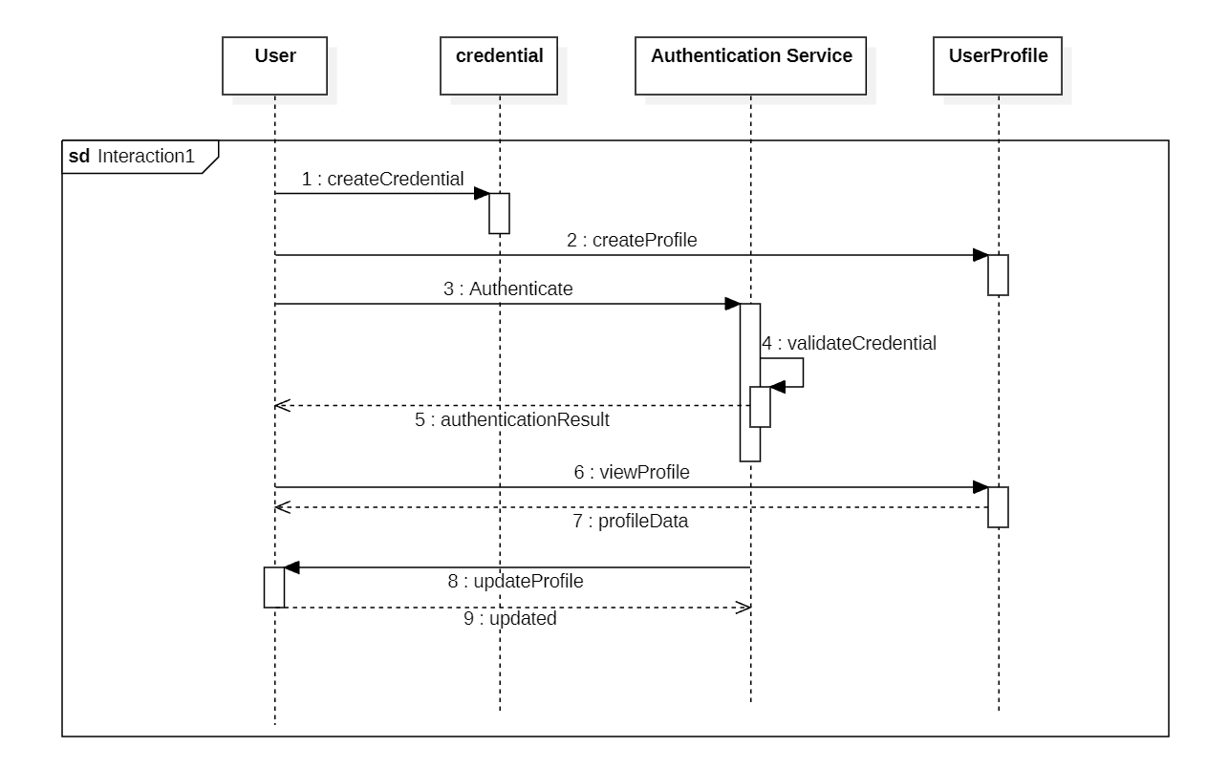

ii) Trip Plan Management & Travel Buddy Discovery

Description: This diagram shows about trip-planning& finding Buddy. A user creates a trip plan, sets
preferences, and gets confirmation. They can view trip details, look for matches with other travelers,
and send request. The user can also update the plan.

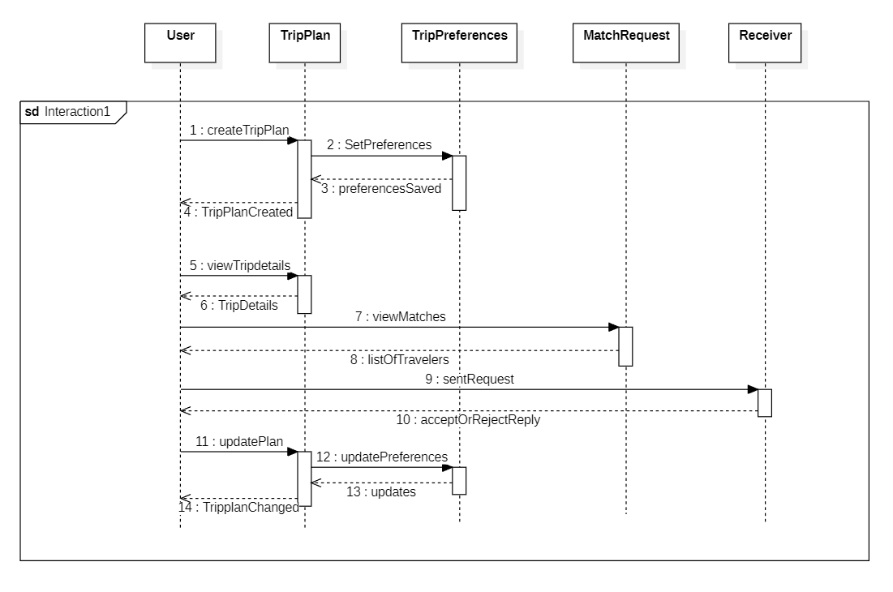

iii) Buddy Interaction & Communication

Description: This diagram shows interactions between User, ChatGroup, Message, Notification,
Settings, and SystemLog. The user creates a chat group, send message, and manages them.
Notifications are sent to participants, and settings can be viewed or updated. System actions are
recorded in the SystemLog.

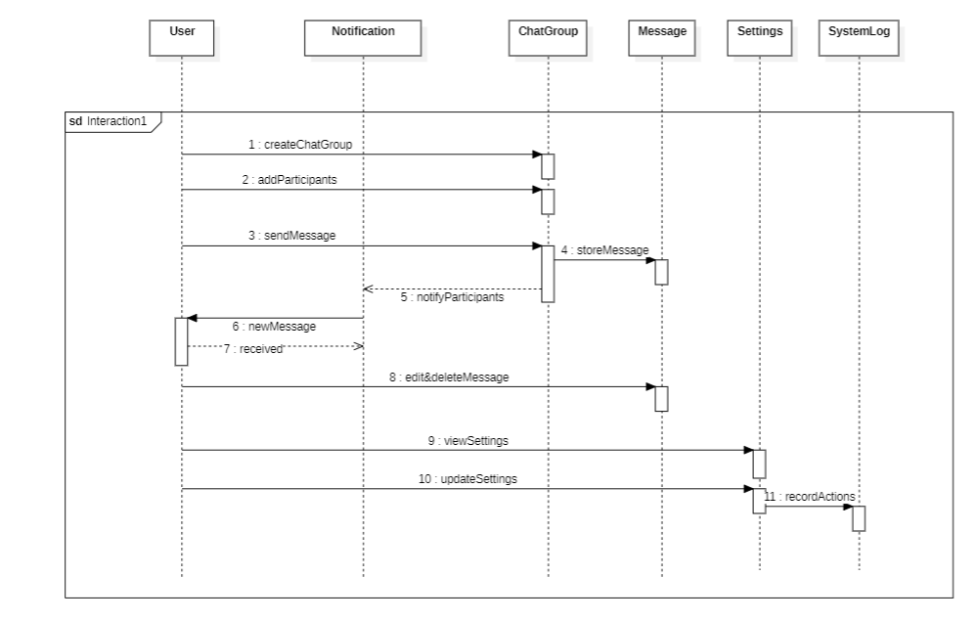

f) Collaboration Diagram

i) User Authentication & profile
Description: This image depicts how User, Credential, UserProfile, and AuthenticationService
interactthrough messages to handle credential creation, authentication validation, and profile
viewing and updating.

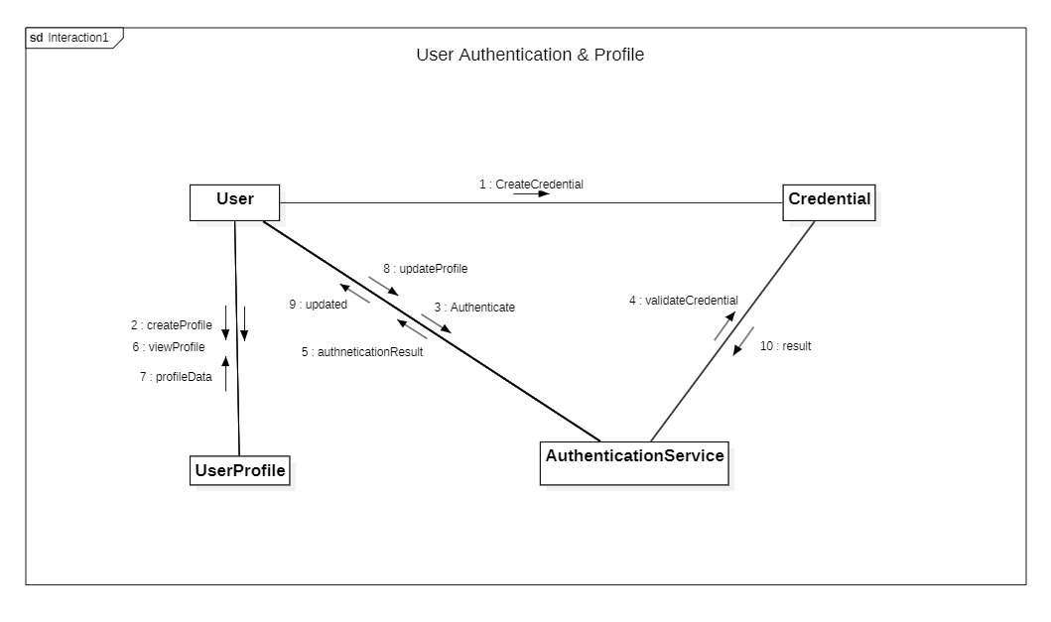

ii) Trip Plan Management

Description: This image describes how the User interacts with TripPlan, TripPreferences,
MatchRequest, and Receiver to create and update trips, set and modify preferences, to view trip
details and matching travelers, and send or receive trip request. The messages indicates the
communication between the different components.
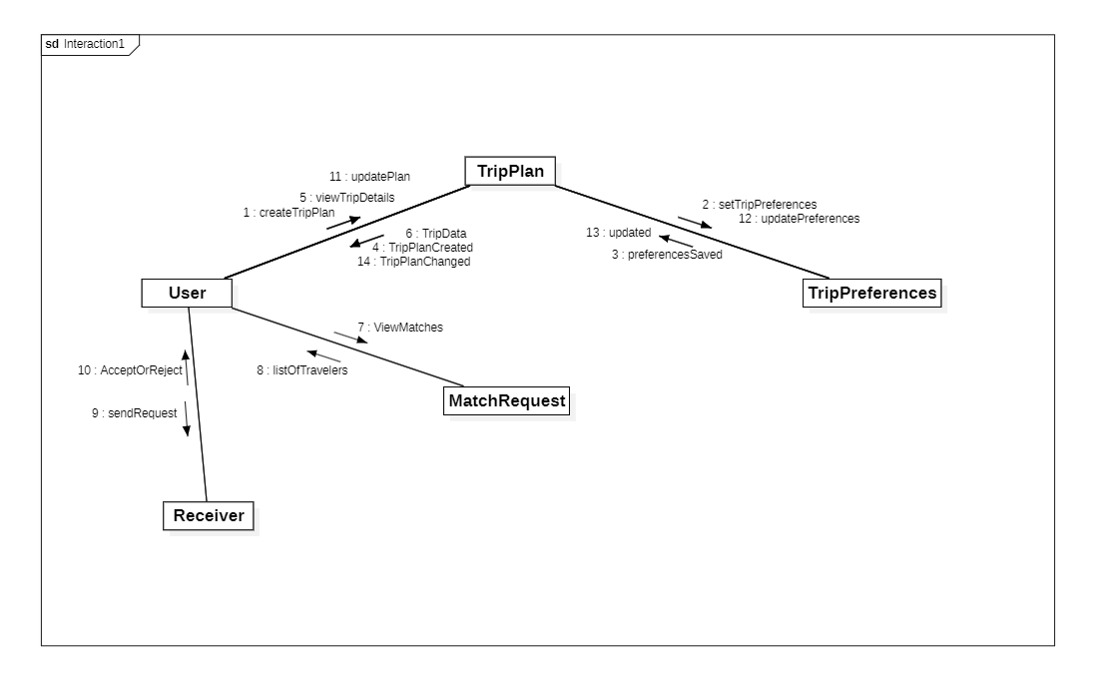

iii) Buddy Interaction & Communication

Description: This diagram explains how the User creates a chat groups, add participants, and send
messages through the chat group. The message component stores the messages and the
notification component informs participants about new messages. The user can also edit or delete
messages and manage settings. All user activities are recorded in the Systemlog.

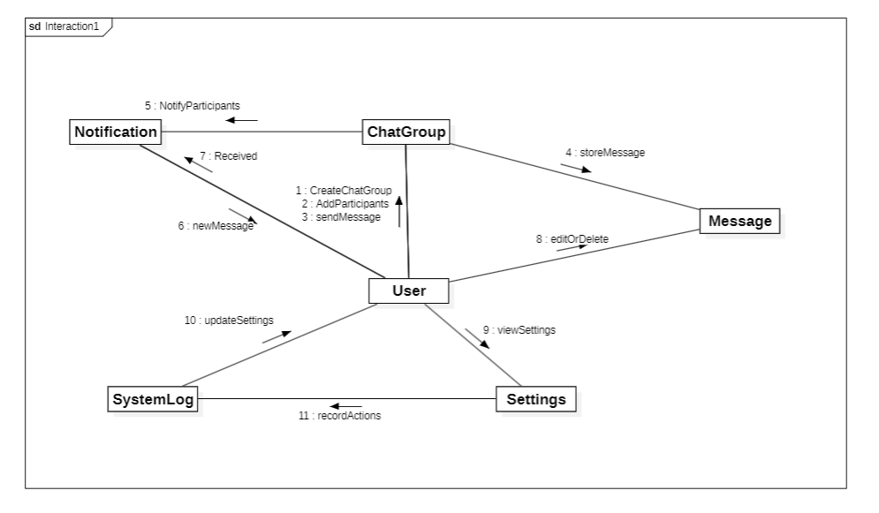

3.2 ER Diagram

Description: ER diagram of system where it allows users to organize their travels and connect with
companions. Each user has personal details stored in the system and can create multiple trips with
destinations, dates, and preferences. Trips are linked through BuddyMatch, which helps pair
travelers and records match status. Users can communicate via ChatMessages, sending and
receiving contentwith timestamps, while notifications keep them updated with alerts about
messages, and matchestrip changes. Altogether, the system integrates trip planning, buddy
matching, messaging, andnotifications into one streamlined platform.

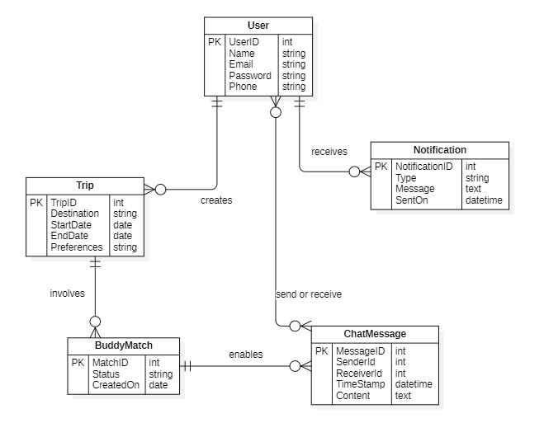

  - DFD Diagram

Description: This diagram illustrates the flow of information between users, processes, and databases. It shows how the system works by connecting Travelers, administrators, and services through five main processes. Travelers log in, manage their profiles and trips, search for buddies, and communicate through chat. The system stores user data, trip details, and records in two main data bases. While notifications are sent via emails or SMS. Admin monitors the alerts to ensure smooth communication.

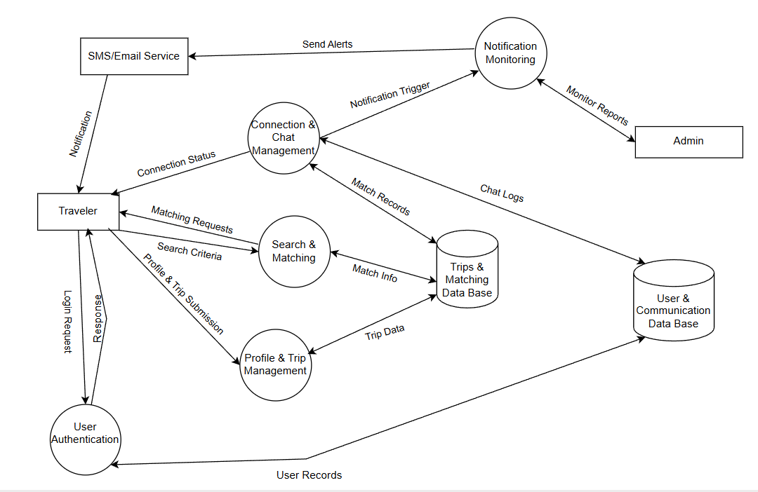

4. External Interface Requirements

  - User Interfaces
Mobile APP UI
- Clean, intuitive design with onboarding screens for profile creation.
- Dashboard showing nearby travelers, suggested matches, and trip plans.
- Chat interface for connecting with buddies.
- Filters for preferences (age, gender, travel style, destination).
Web Interface
- Similar functionality as mobile, optimized for desktop browsers.

4.2 Hardware Interfaces
Mobile Devices
- Android and IOS smartphones with internet connectivity.
- Minimum requirements: like 3GB RAM, Android 10+
Server Hardware
- Cloud-hosted services for backend processing.
- Database servers for storing user profiles, trips, and chat logs.

4.3 Software Interfaces
Operating Systems
- Android, IOS for mobile app.
- Web browsers (Chrome, Safari, Edge) for web version.
APIs
- Firebase/ Socket.IO for real-time chat and notifications.
- Social login APIs.
Database
- Relational Data base (MYSQL/PostgreSQL) for structured data.
- NoSQL (MongoDB) for chat and activity feeds.

4.4 Communication Interfaces
Network Connectivity
- Internet access via Wi-Fi or mobile data.
- Secure communication using HTTPS and encryption technique.
Messaging Protocols
- Real-time communication via WebSockets.
External Communication
- Email notifications for account verification and trip updates.

5. Other Non-Functional Requirements.

5.1 Performance Requirements
- The app should handle at least 10000 current users without lag.
- Search and match results must load within 2-3 seconds.
- Real-time chat and notifications should have latency under 1 second.

5.2 Safety Requirements
- The app should prevent unsafe meetups by encouraging verified profiles and reporting features.
- Emergency contact option should allow users to quickly notify trusted contacts.
- GPS location sharing must be optional and controlled by the user.

5.3 Security Requirements
- All data transmission must use HTTPS with encryption technique.
- User passwords stored with hashing.
- Two-factor authentication.
- Role-based access control for admin and moderators.

5.4 Software Quality Attributes
- Usability: Simple, intuitive UI for travelers of all ages.
- Reliability: 99% uptime with automatic error recovery.
- Scalability: Cloud-based backend to support growing user base.
- Maintainability: Modular code base for easy updates and bug fixes.
- Portability: Works across Android. Ios, and web browsers.

5.5 Business Policies/ Rules.
- Only verified users can initiate chats or meetup requests.
- Free basic membership, premium subscriptions unlocks advanced filters and trip planning tools.
- Strict anti-fraud and anti-harassment policies with account suspension for violations.
- Data privacy aligned with local regulations.

6. Testing
i) I selected the search_trips functionality from my project for testing. This function allows users to
searchfor trips based on destination, budget, and travel date. It validates the input, checks each
trip fromavailable trips and returns different outputs such as Invalid Search Criteria, Exact Matches
Found and the lists of those trips, Partial Match Found and list of those trips, or No Trips Found.

# Search_trips function.

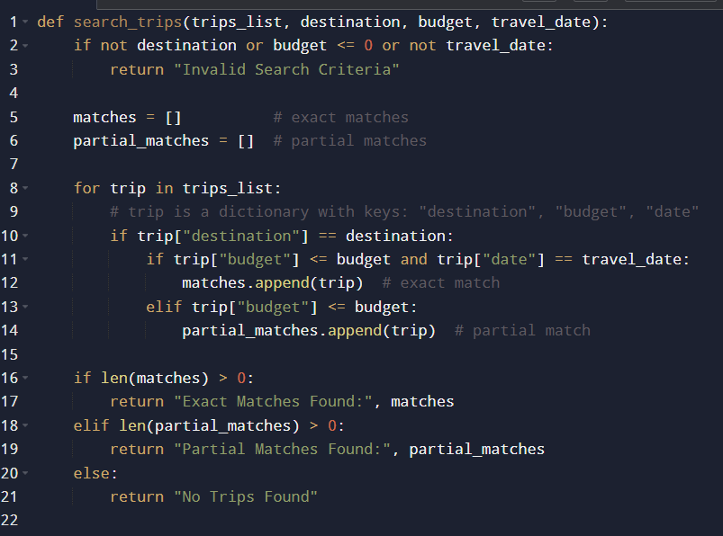

6.1 White-Box Testing

- Control Flow Diagram.

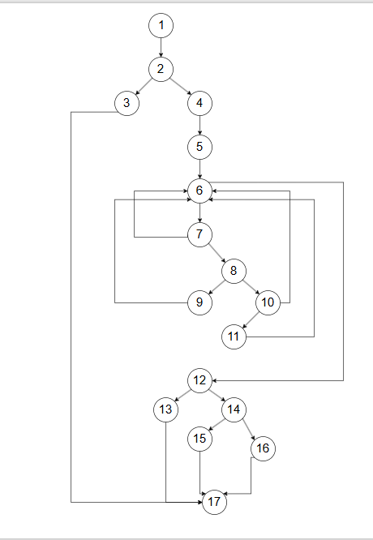

- Cyclomatic Complexity
METHOD 1: Using Number of Inner regions + Outer region.
Inner regions= 7, outer region= 1
Total regions= 8.
METHOD 2: Using Edges and Nodes.
V(G)=E−N+2. E= 23, N=17.
V(G)= 23-17+2= 8
METHOD 3: Using Decision (Predicate) Nodes
V(G) = P+1, P=7
V(G)= 7+1 =8.

- Independent Program Paths
- Path 1: Invalid Search Criteria
1, 2, 3, 17.
- Path 2: No Trips Found (Loop Not Executed=Trip list is empty)
1, 2, 4, 5, 6, 12, 14, 16, 17
- Path 3: One Loop Iteration -> Exact Match Found
1, 2, 4, 5, 6, 7, 8, 9, 6, 12, 13, 17
- Path 4: One Loop Iteration -> Partial Match Found
1, 2, 4, 5, 6, 7, 8, 10, 11, 6, 12, 14, 15, 17
- Path 5: One Loop Iteration -> Destination Not Matching -> No Trips Found
1, 2, 4, 5, 6, 7, 6, 12, 14, 16, 17
- Path 6: One Loop Iteration -> Budget Condition False -> No Trips Found
1, 2, 4, 5, 6, 7, 8, 10, 6, 12, 14, 16, 17
- Path 7: Multiple Loop Iterations (Exact Match After Iterations)
1, 2, 4, 5, 6, 7, 8, 9, 6, 7, 8, 9, 6, 12, 13, 17
- Path 8: Multiple Loop Iterations (Partial Match Only)
1, 2, 4, 5, 6, 7, 8, 10, 11, 6, 7, 8, 10, 11, 6, 12, 14, 15, 17

Path No | Independent Path (Node Sequence) | Test Input | Expected Output
P1 | 1,2,3,17 | trips_list = [{Manali, 22000, 2026-06-10}], destination = "", budget = 25000, travel_date = 2026-06-10 | Invalid Search Criteria
P2 | 1,2,4,5,6,12,14,16,17 | trips_list = [], destination = Manali, budget = 25000, travel_date = 2026-06-10 | No Trips Found
P3 | 1,2,4,5,6,7,8,9,6,12,13,17 | trips_list = [{Manali, 22000, 2026-06-10}], destination = Manali, budget = 25000, travel_date = 2026-06-10 | Exact Matches Found
P4 | 1,2,4,5,6,7,8,10,11,6,12,14,15,17 | trips_list = [{Manali, 23000, 2026-07-01}], destination = Manali, budget = 25000, travel_date = 2026-06-10 | Partial Matches Found
P5 | 1,2,4,5,6,7,6,12,14,16,17 | trips_list = [{Ooty, 21000, 2026-06-10}], destination = Manali, budget = 25000, travel_date = 2026-06-10 | No Trips Found
P6 | 1,2,4,5,6,7,8,10,6,12,14,16,17 | trips_list = [{Manali, 30000, 2026-06-10}], destination = Manali, budget = 25000, travel_date = 2026-06-10 | No Trips Found
P7 | 1,2,4,5,6,7,8,9,6,7,8,9,6,12,13,17 | trips_list = [{Ooty, 21000, 2026-06-10}, {Manali, 23000, 2026-06-10}], destination = Manali, budget = 25000, travel_date = 2026-06-10 | Exact Matches Found
P8 | 1,2,4,5,6,7,8,10,11,6,7,8,10,11,6,12,14,15,17 | trips_list = [{Kerala, 22000, 2026-07-01}, {Manali, 24000, 2026-07-05}], destination = Manali, budget = 25000, travel_date = 2026-06-10 | Partial Matches Found

- Python unittest Code

import unittest

def search_trips(trips_list, destination, budget, travel_date):
if not destination or budget <= 0 or not travel_date:
return "Invalid Search Criteria"
matches = []
partial_matches = []
for trip in trips_list:
if trip["destination"] == destination:
if trip["budget"] <= budget and trip["date"] == travel_date:
matches.append(trip)
elif trip["budget"] <= budget:
partial_matches.append(trip)
if len(matches) > 0:
return "Exact Matches Found:", matches
eliflen(partial_matches) > 0:
return "Partial Matches Found:", partial_matches
else:
return "No Trips Found"

class TestSearchTrips(unittest.TestCase):
def test_p1(self):
trips_list = [{"destination":"Manali","budget":22000,"date":"2026-06-10"}]
self.assertEqual( search_trips(trips_list,"",25000,"2026-06-10"), "Invalid Search Criteria")
def test_p2(self):
trips_list = []
self.assertEqual(search_trips(trips_list,"Manali",25000,"2026-06-10"),"No Trips Found")
def test_p3(self):
trips_list = [{"destination":"Manali","budget":22000,"date":"2026-06-10"}]
result = search_trips(trips_list,"Manali",25000,"2026-06-10")
self.assertEqual(result[0],"Exact Matches Found:")
def test_p4(self):
trips_list = [{"destination":"Manali","budget":23000,"date":"2026-07-01"}]
result = search_trips(trips_list,"Manali",25000,"2026-06-10")
self.assertEqual(result[0],"Partial Matches Found:")
def test_p5(self):
trips_list = [{"destination":"Ooty","budget":21000,"date":"2026-06-10"}]
self.assertEqual(search_trips(trips_list,"Manali",25000,"2026-06-10"),"No Trips Found")
def test_p6(self):
trips_list = [{"destination":"Manali","budget":30000,"date":"2026-06-10"}]
self.assertEqual( search_trips(trips_list,"Manali",25000,"2026-06-10"), "No Trips Found")

def test_p7(self):
trips_list = [
{"destination":"Ooty","budget":21000,"date":"2026-06-10"},
{"destination":"Manali","budget":23000,"date":"2026-06-10"}
]
result = search_trips(trips_list,"Manali",25000,"2026-06-10")
self.assertEqual(result[0],"Exact Matches Found:")
def test_p8(self):
trips_list = [
{"destination":"Kerala","budget":22000,"date":"2026-07-01"},
{"destination":"Manali","budget":24000,"date":"2026-07-05"}
]
result = search_trips(trips_list,"Manali",25000,"2026-06-10")
self.assertEqual(result[0],"Partial Matches Found:")

if __name__ == "__main__":
suite = unittest.TestLoader().loadTestsFromTestCase(TestSearchTrips)
unittest.TextTestRunner(verbosity=2).run(suite)

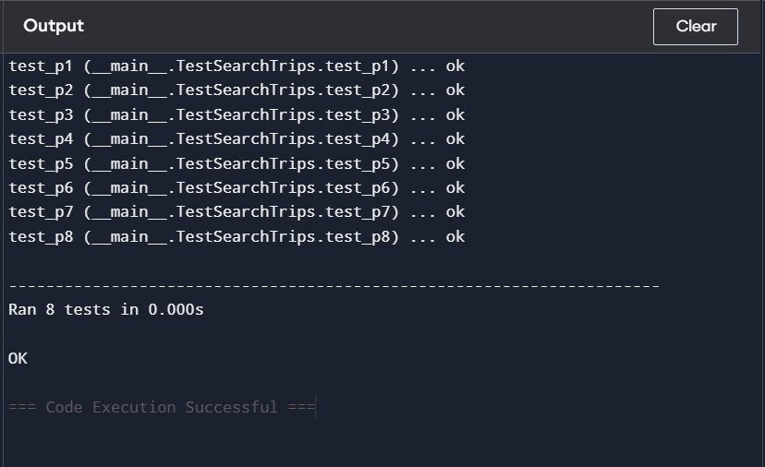

6.2 Black-box Testing
- Step 1: Functional Requirements (From Problem Statement)
For search_trips() module:
- Destination must not be empty, budget must be greater than 0, and travel date must be provided.
- If destination is empty OR budget is less than or equal to 0 OR travel date is missing -> return "Invalid Search Criteria"
- If no trip exists in the list that matches the given destination and budget -> return "No Trips Found"
- If a trip matches the destination, the trip budget is within the given budget, and the travel date is the same -> return "Exact Matches Found"
- If a trip matches the destination and the trip budget is within the given budget but the travel date is different -> return "Partial Matches Found"
- If no exact match or partial match is found after checking all trips -> return "No Trips Found"

- Equivalence Partitioning
Dividing inputs into logical groups:
Class | Range / Condition | Valid / Invalid
EC1 | Destination is empty OR budget ≤ 0 OR travel date is empty | Invalid
EC2 | Destination is provided AND budget > 0 AND travel date is provided | Valid
For Outputs:
Class | Condition | Output
EC3 | Destination, budget and date match | Exact Matches Found
EC4 | Destination and budget match but date differs | Partial Matches Found
EC5 | No trips satisfy the conditions | No Trips Found
EC6 | Destination is empty OR budget ≤ 0 OR date is empty | Invalid Search Criteria

- Boundary Value Analysis

BB No | Test Input (Destination, Budget, Date) | Expected Output | Technique
BB1 | ["Manali", -1, "2026-06-10"] | Invalid Search Criteria | Budget below boundary (0)
BB2 | ["Manali", 0, "2026-06-10"] | Invalid Search Criteria | Budget boundary (0)
BB3 | ["Manali", 1, "2026-06-10"] | Valid Search Performed | Budget just above boundary
BB4 | ["", 15000, "2026-06-10"] | Invalid Search Criteria | Destination empty boundary
BB5 | ["Manali", 15000, ""] | Invalid Search Criteria | Date empty boundary
BB6 | ["Manali", 15000, "2026-06-10"] | Exact Matches Found | Valid boundary condition
BB7 | ["Manali", 15000, "2026-06-09"] | Partial Matches | Date near boundary

- Testing few test cases

# trips list
trips_list = [
{"destination": "Manali", "budget": 15000, "date": "2026-06-10"},
{"destination": "Manali", "budget": 15000, "date": "2026-06-09"},
{"destination": "Ooty", "budget": 12000, "date": "2026-06-10"}
]

print(search_trips(trips_list, "Manali", -1, "2026-06-10"))
print(search_trips(trips_list, "Manali", 0, "2026-06-10"))
print(search_trips(trips_list, "Manali", 1, "2026-06-10"))
print(search_trips(trips_list, "", 15000, "2026-06-10"))
print(search_trips(trips_list, "Manali", 15000, ""))
print(search_trips(trips_list, "Manali", 15000, "2026-06-10"))
print(search_trips(trips_list, "Manali", 15000, "2026-06-09"))

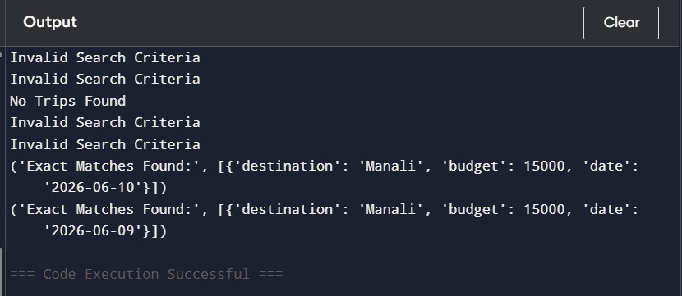

ii) I selected the login function from my project for testing. This function lets a user log in by entering a
username and password. It first checks if the inputs are given. Then it verifies whether the user exists in
the database, whether the account is active, and whether the password is correct. Based on these
checks, it returns results such as Invalid Input, User Not Found, Account Deactivated, Incorrect
Password, or Login Successful.

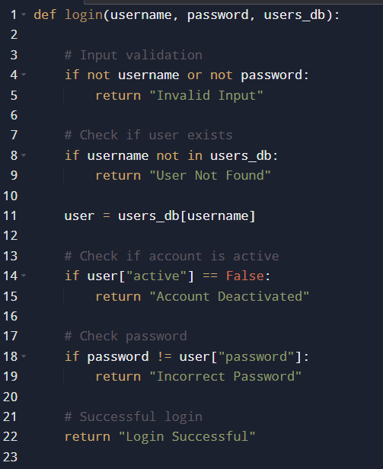

6.1 White-Box Testing
- Control Flow Diagram.

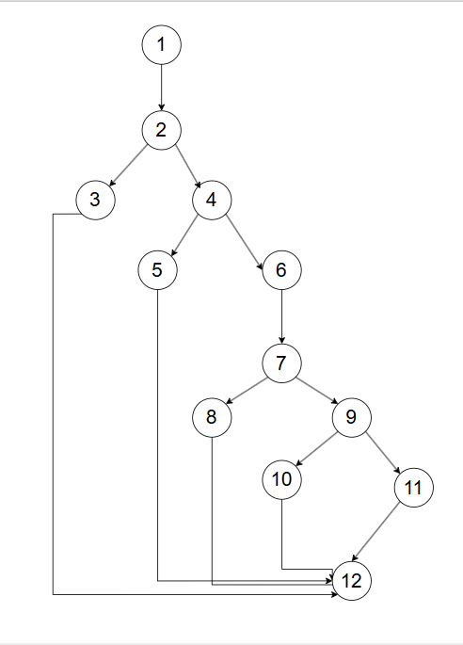

- Cyclomatic Complexity
METHOD 1: Using Number of Inner regions + Outer region.
Inner regions= 4, outer region= 1
Total regions= 5.
METHOD 2: Using Edges and Nodes.
V(G)=E−N+2. E= 15, N=12.
V(G)= 15-12+2= 5
METHOD 3: Using Decision (Predicate) Nodes
V(G) = P+1, P=4
V(G)= 4+1 =5.

- Independent Program Paths
- Path 1: Invalid Input (Username or Password Missing)
1, 2, 3, 12
- Path 2: User Not Found (Username Not Present in Database)
1, 2, 4, 5, 12
- Path 3: Account Deactivated (User Exists but Account is Inactive)
1, 2, 4, 6, 7, 8, 12
- Path 4: Incorrect Password (User Exists, Active but Password Mismatch)
1, 2, 4, 6, 7, 9, 10, 12
- Path 5: Successful Login (All Conditions Satisfied)
1, 2, 4, 6, 7, 9, 11, 12
Path | Independent Path | Test Input | Expected Output
P1 | 1, 2, 3, 12 | username = "", password = "45@hry",  users_db = {"mahi": {"password": "5#2dg", "active": True}} | Invalid Input
P2 | 1, 2, 4, 5, 12 | username = "sana", password = "7*9lpq",  users_db = {"mahi": {"password": "5#2dg", "active": True}} | User Not Found
P3 | 1, 2, 4, 6, 7, 8, 12 | username = "mizzu", password = "k9@bvc",  users_db = {"mizzu": {"password": "m2$ty9", "active": False}} | Account Deactivated
P4 | 1, 2, 4, 6, 7, 9, 10, 12 | username = "cherry", password = "p8&xzy",  users_db = {"cherry": {"password": "q4#mn2", "active": True}} | Incorrect Password
P5 | 1, 2, 4, 6, 7, 9, 11, 12 | username = "sony", password = "r3$yt7",  users_db = {"sony": {"password": "r3$yt7", "active": True}} | Login Successful

- Python unittest Code

import unittest

def login(username, password, users_db):
if not username or not password:
return "Invalid Input"
if username not in users_db:
return "User Not Found"
user = users_db[username]
if user["active"] == False:
return "Account Deactivated"
if password != user["password"]:
return "Incorrect Password"
return "Login Successful"

classTestLogin(unittest.TestCase):
def test_p1(self):
users_db = {"mahi": {"password": "5#2dg", "active": True}}
self.assertEqual(login("", "45@hry", users_db), "Invalid Input")
def test_p2(self):
users_db = {"mahi": {"password": "5#2dg", "active": True}}
self.assertEqual(login("sana", "7*9lpq", users_db), "User Not Found")
def test_p3(self):
users_db = {"mizzu": {"password": "m2$ty9", "active": False}}
self.assertEqual(login("mizzu", "k9@bvc", users_db), "Account Deactivated")
def test_p4(self):
users_db = {"cherry": {"password": "q4#mn2", "active": True}}
self.assertEqual(login("cherry", "p8&xzy", users_db), "Incorrect Password")
def test_p5(self):
users_db = {"sony": {"password": "r3$yt7", "active": True}}
self.assertEqual(login("sony", "r3$yt7", users_db), "Login Successful")

if __name__ == "__main__":
suite = unittest.TestLoader().loadTestsFromTestCase(TestLogin)
unittest.TextTestRunner(verbosity=2).run(suite)

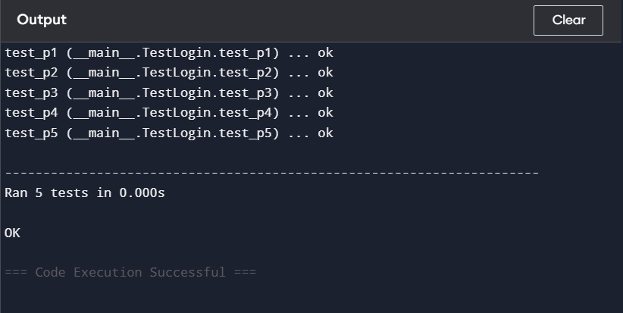

6.2 Black-box Testing

- Step 1: Functional Requirements (From Problem Statement)
For login() module:
- Username must not be empty, and password must be provided.
- If username is empty OR password is empty → return "Invalid Input".
- If the username does not exist in the users_db → return "User Not Found".
- If the user exists but the account is inactive (active = False) → return "Account Deactivated".
- If the user exists, account is active, but password does not match the stored password → return "Incorrect Password".
- If the user exists, account is active, and password matches the stored password → return "Login Successful".

    - Equivalence Partitioning
Dividing inputs into logical groups:
Class | Range / Condition | Valid / Invalid
EC1 | Username is empty OR password is empty OR username does not exist in users_db OR account is inactive OR password does not match | Invalid
EC2 | Username is provided AND exists in users_db AND account is active AND password matches | Valid

For Output:
Class | Condition | Output
EC3 | Username is empty OR password is empty | Invalid Input
EC4 | Username does not exist in users_db | User Not Found
EC5 | Username exists but account is inactive (active = False) | Account Deactivated
EC6 | Username exists, account active, but password does not match | Incorrect Password
EC7 | Username exists, account active, and password matches | Login Successful

    - Testing few test cases

# Sample users database
users_db = {
"mahi": {"password": "5#2dg", "active": True},
"sana": {"password": "7*9lpq", "active": True},
"mizzu": {"password": "k9@bvc", "active": False},
"cherry": {"password": "p8&xzy", "active": True},
"sony": {"password": "r3$yt7", "active": True}
}

print(login("", "45@hry", users_db))
print(login("sana", "", users_db))
print(login("unknown_user", "7*9lpq", users_db))
print(login("mizzu", "k9@bvc", users_db))
print(login("cherry", "wrongpass", users_db))
print(login("sony", "r3$yt7", users_db
print(login("mahi", "5#2dg", users_db))

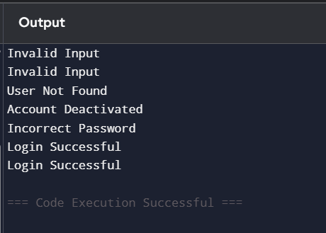
7. Conclusion
- The Travel Hive system was developed to help travelers connect with others who are planning to visit the same destination at similar times. It provides a platform where users can create profiles,
plan trips, find travel companions, and share travel information.
- During the project development, software engineering techniques such as UML, ER, and DFD
diagrams were used to design the system. White-box and black-box testing were also conducted to
verify key functions like trip searching and user login.
- Overall, the Travel Hive system successfully provides a structured platform for travelers to
coordinate and share travel plans with others who have similar travel interests.

8. References
[1] C. Patil, S. Davli, S. Nawale, P. Shetty, and T. Tikhe, “A Survey On: Travel Recommendation System,”TIJER – International Research Journal, vol. 11, no. 10, pp. a556–a558, Oct. 2024. [Online]. Available:
Various online tutorials and educational resources related to UML modeling, and software testing.

9. Acknowledgements
I sincerely thanks toour faculty for clear teaching, and guiding throughout the preparation of this SRS.
Their valuable advice helped to understand software engineering concepts and complete the
document successfully.

DESIGN
ARCHITECTURE

- Component level design

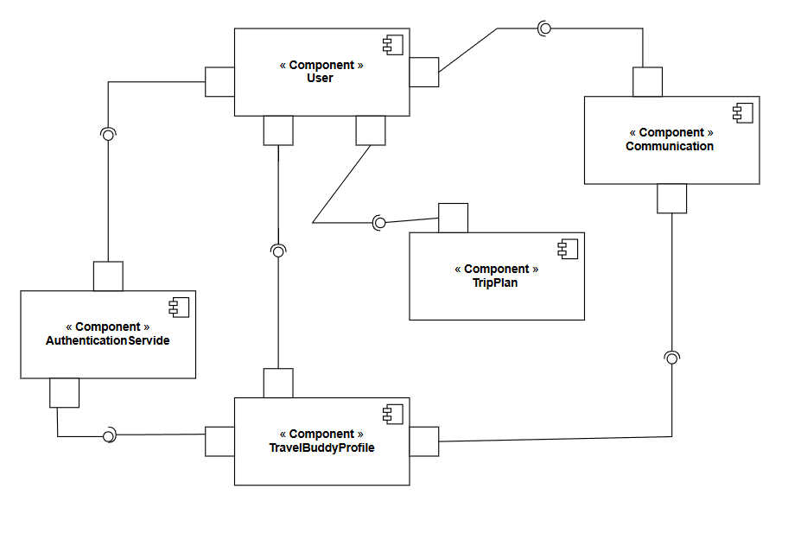

Description:
The UML Component Diagram shows the main components of the Travel Buddy system. The diagram includes User, AuthenticationService, TravelBuddyProfile, TripPlan, and Communication. These components are connected through interfaces to represent their interaction. AuthenticationService manages user login and verification, TravelBuddyProfile stores user profile details, TripPlan handles travel planning, and Communication allows users to interact. The diagram helps explain how the different parts of the system work together.

- Deployment Design

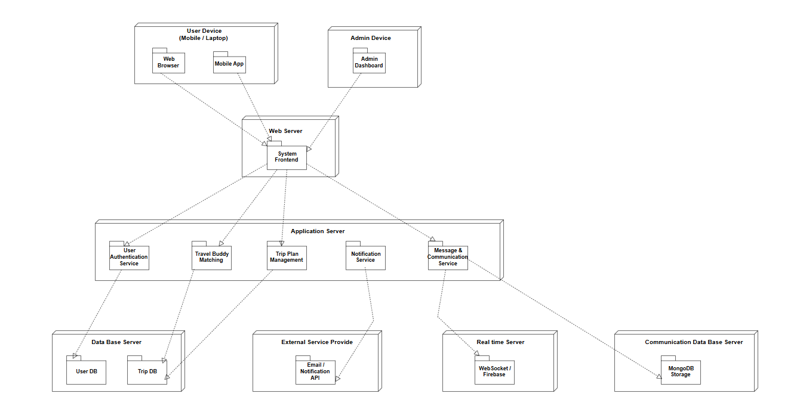

Description:
This deployment diagram explains how the Travel Hive system is arranged across different devices and servers. Users can access the platform using a mobile application or a web browser, while administrators control the system through the admin dashboard. The web server provides the frontend interface and communicates with the application server, where the main system services such as authentication, travel buddy matching, trip management, messaging, and notifications are handled. The application server stores and retrieves data from the database server and also connects with real-time services and external notification APIs through network communication.

Product Metrics

Function-Based Metrics
FP = UFP * CAF
- Calculate the Count total (or) UFP

Information Domain Value | Count | Weight Factor
 |  | Simple | Average | Complex
External Inputs (EIs) | 8 | 3 | 4 | 6
External Outputs (EOs) | 5 | 4 | 5 | 7
External Inquiries (EQs) | 5 | 3 | 4 | 6
Internal Logical Files (ILFs) | 6 | 7 | 10 | 15
External Interface Files (EIFs) | 4 | 5 | 7 | 10

Information Domain Value | Count | Simple (x1 × Factor) | Average (x2 × Factor) | Complex (x3 × Factor) | Total
EI (External Inputs) | 8 | 3 × 3 = 9 | 4 × 4 = 16 | 1 × 6 = 6 | 31
EO (External Outputs) | 5 | 2 × 4 = 8 | 2 × 5 = 10 | 1 × 7 = 7 | 25
EQ (External Inquiries) | 5 | 2 × 3 = 6 | 2 × 4 = 8 | 1 × 6 = 6 | 20
ILF (Internal Logical Files) | 6 | 2 × 7 = 14 | 3 × 10 = 30 | 1 × 15 = 15 | 59
EIF (External Interface Files) | 4 | 1 × 5 = 5 | 2 × 7 = 14 | 1 × 10 = 10 | 29

UFP (Unadjusted Function Points)= 164

- Calculate Complexity Adjustment Factor (CAF or VAF)

The Value adjustment factors

1. Does the system require reliable backup and recovery?
2. Are specialized data communications required to transfer information to or from the application?
3. Are there distributed processing functions?
4. Is performance critical?
5. Will the system run in an existing, heavily utilized operational environment?
6. Does the system require online data entry?
7. Does the online data entry require the input transaction to be built over multiple screens or operations?
8. Are the ILFs updated online?
9. Are the inputs, outputs, files, or inquiries complex?
10. Is the internal processing complex?
11. Is the code designed to be reusable?
12. Are conversion and installation included in the design?
13. Is the system designed for multiple installations in different organizations?
14. Is the application designed to facilitate change and ease of use by the user?
Rating | Factors | Count | Partial Sum (Rating × Count)
0 | None | 0 | 0
1 | F3, F11 | 2 | 2 × 1 = 2
2 | F2, F12, F13 | 3 | 2 × 3 = 6
3 | F4, F5, F7 | 3 | 3 × 3 = 9
4 | F9, F10, F14 | 3 | 4 × 3 = 12
5 | F1, F6, F8 | 3 | 5 × 3 = 15

- Σ Fi = 2+6+9+12+15 = 44.
- CAF = 0.65 + ( 0.01 * ∑(Fi ))
CAF = 0.65+(0.01×44)
CAF = 0.65+0.44
CAF = 1.09

- Calculating Function Point

FP = UFP * CAF
FP = 164 * 1.09
FP = 178.76

iV. Applications of Functional Point.

- Total Development Hours
If historically 1 FP = 10 hours of development:
178.76×10 = 1787.6 hours
- Project Cost Estimation
If Developer cost = ₹1000 per hour:
1787.6×1000 = ₹1,787,600
- Maintenance Effort Estimation
Assume maintenance requires 20% of total development effort:
1787.6×0.2 = 357.52 hours
Cost for maintenance (₹1000/hour):357.52×1000 = ₹357,520

- Contract / Client Pricing
If client pays ₹1000 per FP:178.76×1000=₹178,760
- Complexity Comparison
My Project FP = 178.76
Other Project FP = 220
Comparison : 178.76 / 220 = 0.81
We can interpret that My project is less complex than the 220 FP project

Empirical Estimation Models-COCOMO Model

COCOMO Model
- COCOMO (Constructive Cost Model) is a regression model based on the number of Lines of Code (LOC).
- It is a procedural cost estimation model for software projects.
- This model is used for predicting the various parameters associated with developing a project such as size, effort, cost, and time.

i) Project Category- Organic.
“The estimated size of the Travel Hive system is approximately 12 KLOC”
ii) Types of COCOMO Models.
- Basic COCOMO model - Predicted software size (lines of code) is used to estimate development effort.
- Intermediate COCOMO model - Predicted software size (lines of code), along with a set of 15 subjectively assessed “cost drivers,” is used to estimate development effort.

- Basic COCOMO Model.
- The following formulas are used to calculate effort and time estimates:
Effort (E) = A * (KLOC)^B
Time (T) = C * (Effort)^D
Persons required = Effort / Time
- The constant values A, B, C and D for the Basic Model for the Organic category of software project is:
Software Project | A | B | C | D
Organic | 2.4 | 1.05 | 2.5 | 0.38

Organic Mode:
- Effort (E) = A * (KLOC) ^B.
Effort (E) = 2.4*(12)^1.05.
Effort (E) = 32.61 Person-Months.
- Time (T) = C * (Effort)^D
Time (T) = 2.5*(32.61)^0.38.
Time (T) = 9.4 Months.

2) Intermediate COCOMO Model.
- In the intermediate COCOMO model, various other factors such as reliability, experience, and
capability are considered along with LOC to estimate effort and time schedule.
- These factors are known as Cost Drivers, and the Intermediate Model utilizes 15 such drivers for cost
estimation.
i) Product Attributes
- Required Software Reliability extent-Nominal
- Size of the application database - Nominal
- The complexity of the product - Nominal
ii) Hardware attributes:
4. Run-time performance constraints - Low
5. Memory constraints - Low
7. Required turnaround time – Nominal

(iii) Personnel attributes:
8. Analyst capability - Nominal
9. Software engineering capability - Nominal
10. Applications experience - Low
12. Programming language experience – Nominal
(iv) Project attributes:
13. Use of software tools - High
14. Application of software engineering methods - Nominal
15. Required development schedule - Nominal

Cost drivers Number | Very low | Low | Nominal | High | Very high | Extra high
1 | 0.75 | 0.88 | 1.00 | 1.15 | 1.40 | -
2 | - | 0.94 | 1.00 | 1.08 | 1.16 | -
3 | 0.70 | 0.85 | 1.00 | 1.15 | 1.30 | 1.65
4 | - | - | 1.00 | 1.11 | 1.30 | 1.66
5 | - | - | 1.00 | 1.06 | 1.21 | 1.56
6 | - | 0.87 | 1.00 | 1.15 | 1.30 | -
7 | - | 0.87 | 1.00 | 1.07 | 1.15 | -
8 | 1.46 | 1.19 | 1.00 | 0.86 | 0.71 | -
9 | 1.29 | 1.13 | 1.00 | 0.91 | 0.82 | -
10 | 1.42 | 1.17 | 1.00 | 0.86 | 0.70 | -
11 | 1.21 | 1.10 | 1.00 | 0.90 | - | -
12 | 1.14 | 1.07 | 1.00 | 0.95 | - | -
13 | 1.24 | 1.10 | 1.00 | 0.91 | 0.82 | -
14 | 1.24 | 1.10 | 1.00 | 0.91 | 0.83 | -
15 | 1.23 | 1.08 | 1.00 | 1.04 | 1.10 | -

- EAF = (9 * (1.00))*1.17 * 0.91.
EAF = 9.58.
- Effort (E) = (A*(KLOC)^B) * EAF.
- Time (T) = C*(Effort)^D
- Persons required = Effort / Time

Software Project | A | B | C | D
Organic | 3.2 | 1.05 | 2.5 | 0.38

- Effort (E) = (3.2 *(12^1.05)*9.58)
Effort (E) = 416.54.
- Time (T) = (2.5*(416.54^0.38))
Time (T) = 24.74.
- Persons required = 416.54/24.74
Persons required = 16.84 = 17.

